Requirements:

a. Tomcat Server
b. MySQL Server
c. Android device

Installation & Setup:

    - Install Tomcat server and make sure it is running properly.

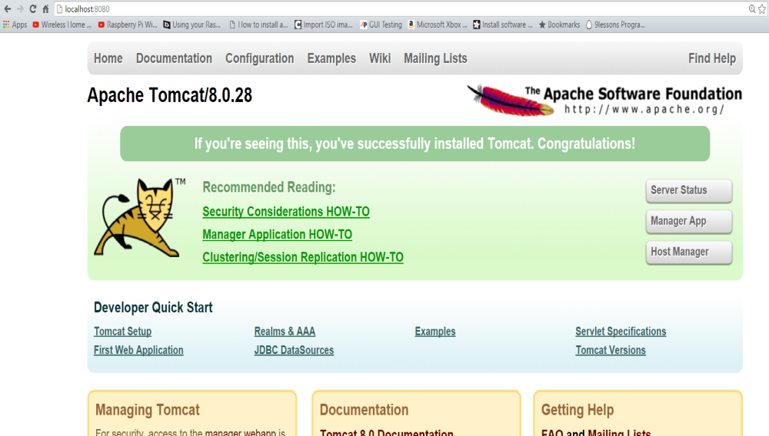
    - Install MYSQL database and make sure it is running properly.

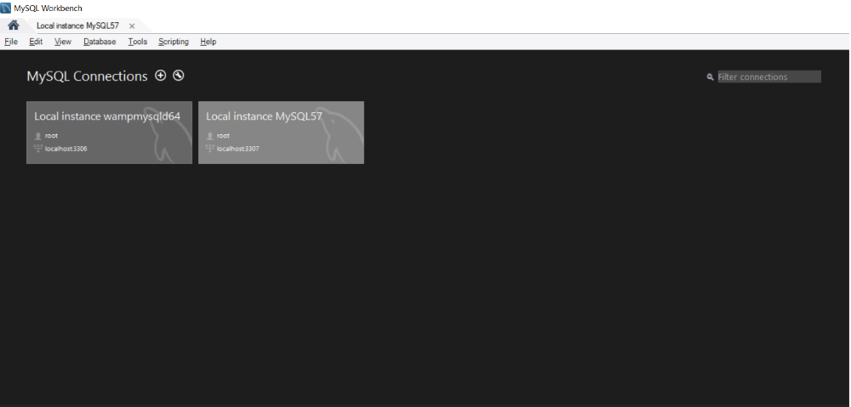

    - Create the database called campusconnect in the MYSQL and create the all the required tables as in CampusConnectDB.sql file.

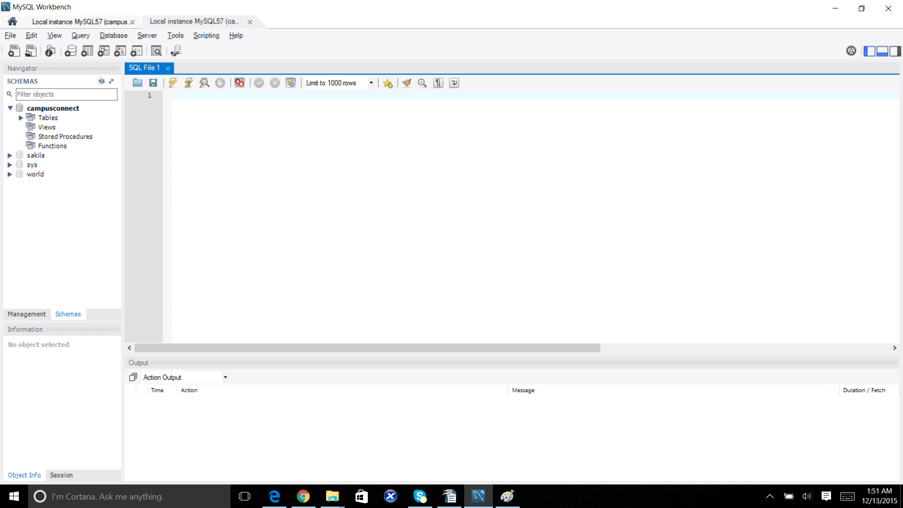
    - Place the both (CampusConnect.war, CampusConnectChat.war) files in the tomcat server. (Deploy)

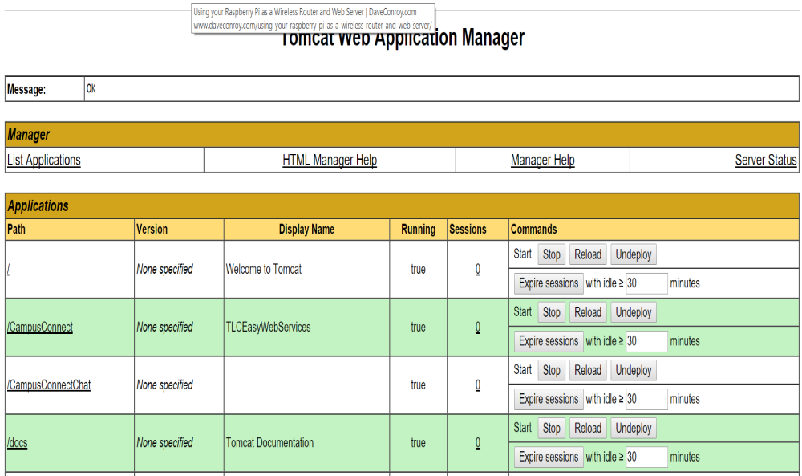

    - Install the both (CampusConnectUser.apk and CcadminTest,apk) files in the android device.

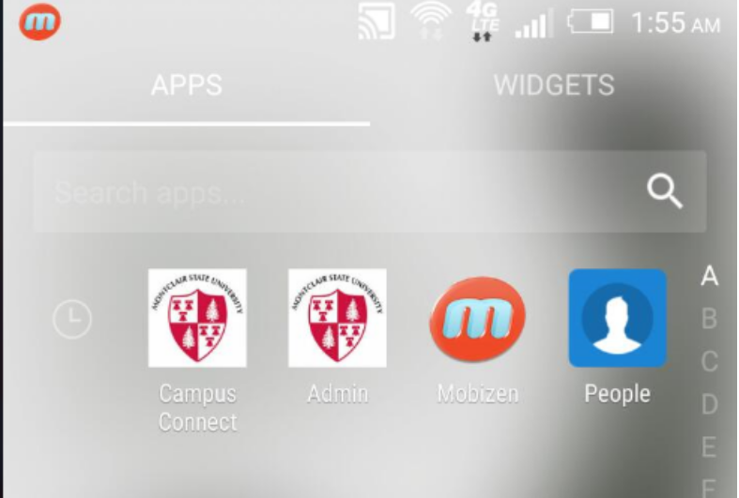
    - After the installtion check the IP address of the system. This is the server IP address which communicates both user and admin applications.

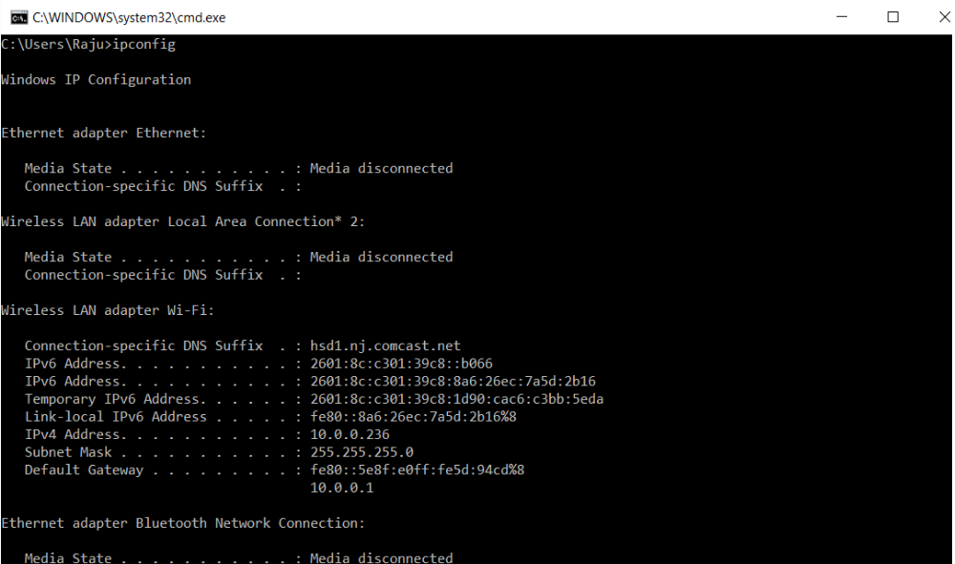

    - Place the IP address in the application settings on home screen.

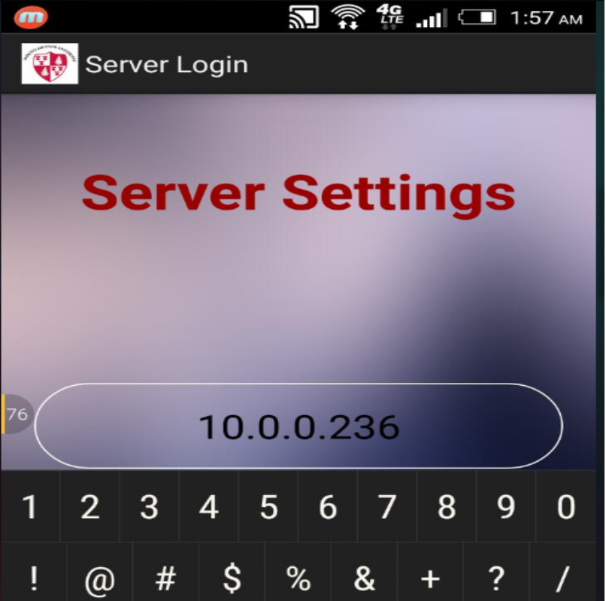

    - Finally, navigate through the application for all the functions.

